Summary of Azure AD External Identities Video
This video provides an in-depth explanation of Azure AD External Identities, a new feature introduced in GA8 that unifies and extends Azure Active Directory’s (Azure AD) external identity capabilities. The presenter clarifies the differences between existing Azure AD identity models and outlines the enhancements brought by External Identities to improve collaboration and customer identity management.

Core Concepts and Existing Azure AD Identity Models
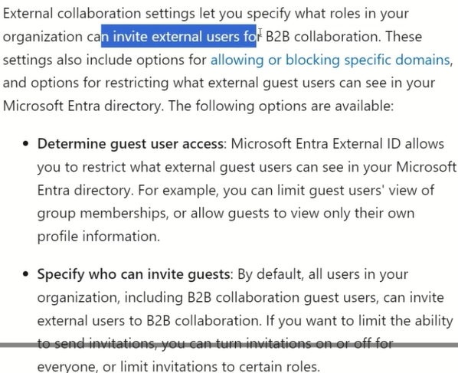
- Azure AD Tenant: The core directory where internal users reside; accounts can be synchronized from on-premises AD or created directly in the cloud.
- Azure AD B2B (Business-to-Business): Enables collaboration with external partners who may use various identity providers (Microsoft accounts, Google/Gmail, direct federation via SAML/WS-Fed, or one-time passcodes). External guests become objects within the host Azure AD tenant.
- Azure AD B2C (Business-to-Customer): Designed for customer-facing applications with separate tenants, supporting a vast range of social identity providers and local accounts. Highly customizable onboarding experience, UI, and attribute collection.
- Entitlement Management: A feature enabling self-service access packages for B2B users, automating group/application access and approval workflows.

Azure AD External Identities: What It Is
- External Identities acts as an umbrella term that encompasses both Azure AD B2B and B2C capabilities.
- It unifies the external collaboration and customer identity management under a single family, while introducing new features, especially for B2B scenarios.

Key New Features in External Identities for B2B
- Self-Service User Sign-Up: Allows external users to onboard themselves via a configurable user flow in the Azure AD tenant.
- New Social Identity Provider Support: Introduction of Facebook as a new identity provider for B2B external users, enabled through custom application registration and user flows.
- Custom User Attributes: Ability to define and collect additional custom attributes (e.g., shirt size) during user sign-up, stored as extension attributes linked to a special Azure AD app registration.
- Customizable User Flows: Admins can design the onboarding process, selecting which identity providers to allow, what attributes to collect, their order, and input types (e.g., radio buttons for shirt size).
- Application Integration: User flows can be linked to specific applications, enabling seamless authentication and attribute collection for external users.

Licensing Model Updates
Licensing Aspect | Previous Model | External Identities Model
B2B Licensing | 1:5 ratio (for every licensed internal user, 5 guests can use license) | Option to switch to Monthly Active Users (MAU) billing, similar to B2C
Free Tier | Not specified | First 50,000 monthly active external users free
MFA Charges | Included in P1/P2 licensing | Billed separately per MFA attempt
- The MAU billing model removes the restrictive 1:5 licensing ratio, enabling larger guest user bases with P1/P2 capabilities.
- MFA (Multi-Factor Authentication) is billed separately but included in the licensing for internal users.

Detailed Workflow Overview
- Admins enable guest self sign-up in the Azure AD tenant’s external identities settings.
- Enabling self sign-up creates a special “aad extensions app” automatically, used to store custom attributes.
- Facebook is added as an identity provider by creating a Facebook developer app and linking its App ID and secret in Azure AD.
- External users sign up through a configurable user flow selecting Facebook or other providers, providing required attributes.
- Custom attributes collected during sign-up are stored as extension properties in Azure AD and accessible via Microsoft Graph API.
- External users become guests in the Azure AD tenant with appropriate access and licensing.
- The sign-up experience and attribute collection are fully customizable, including attribute types and UI order.

Practical Demonstration Highlights
- The presenter demonstrated deleting and re-adding a Facebook user guest via self-sign-up.
- Showed the process of verifying email, entering custom attributes (like shirt size), and completing onboarding.
- Demonstrated retrieving custom attribute data from the Microsoft Graph API.
- Showed how to link the user flow to a sample Node.js single-page application using implicit OAuth flow.
- Explained how dynamic group assignment or further automation could be layered on top, though not provided out-of-the-box.

Summary of Benefits and Recommendations
- External Identities unifies Azure AD B2B and B2C, simplifying identity management for organizations with both partner and customer scenarios.
- New B2B capabilities add social login options (starting with Facebook), custom attributes, and more flexible self-service user onboarding.
- Monthly Active Users licensing model for B2B reduces costs and scales better than traditional 1:5 guest licensing.
- Organizations should continue using Azure AD B2C for customer scenarios needing broad social identity support and deep UI customization.
- For partner collaboration, External Identities offers a more flexible and extensible approach, potentially moving some customer scenarios into B2B in the future.
- The feature is currently in general availability and evolving, with expectations for more social identity providers to be added to B2B over time.

Key Terms and Definitions
Term | Definition
Azure AD B2B | External collaboration with partners using Azure AD guest accounts.
Azure AD B2C | Customer identity management with separate tenants and broad social identity support.
External Identities | New umbrella feature combining B2B and B2C with new enhancements, especially for B2B.
User Flow | Customizable onboarding process for external users specifying identity providers and attributes.
Custom Attributes | Additional user attributes defined by admins, stored as extension properties.
Monthly Active Users (MAU) | Licensing model charging based on number of active users per month rather than per guest.
Entitlement Management | Access package and workflow management for user access provisioning.
This video is a comprehensive technical overview of Azure AD External Identities, emphasizing unification, new social logins, customizable user onboarding, and flexible licensing as the key enhancements shaping external collaboration and consumer identity experiences in Azure AD.

